

**ONLINE SHOPPING CART ANALYSIS TO UNDERSTAND THE**

**CUSTOMER’S ONLINE EXPENDITURE PATTERN**

*A PROJECT REPORT*

*For*

**DATA MINING TECHNIQUES (ITE2006)**

**in**

**B.Tech – Information Technology and Engineering**

*by*

|  |  |
| --- | --- |
| ***Name*** | ***Registration number*** |
| *AMAN SOMANI* | ***19BIT0166*** |
| *RITWIK SUKHIJA* | ***19BIT0411*** |
| *VISHNU PRABHAKAR* | ***19BIT0043*** |

Under the guidance of

Prof. Valarmathi B

**Google Drive Link :**

**https://drive.google.com/drive/folders/1rY7Ri_eaGTs8TWxXq5Dbyfej0o-2q-Ka?usp=sharing**

**Abstract :**

In day-to-day activities huge amounts of data are generated, as a result the volume of data is increasing dramatically. Mining information from this explosive growth of data has become one of the major challenges for data management and mining communities. Moreover, the majority of the recognized organizations collect and store massive amounts of customer transaction data. However, having these massive data do not mean the organizations had rich commercial information. The business industries need to discover valuable information and knowledge from this vast quantity of data. This leads us to online shopping cart analysis. Shopping cart analysis aims at finding out purchasing patterns by discovering important associations among the products which they place in their online shopping carts. It not only assists in decision making process but also increases sales in many e-commerce websites like amazon, flipkart etc... Apriori, FP Growth and Eclat are the most common algorithms for mining frequent itemsets. For all of these algorithms predefined minimum support is needed to satisfy for identifying the frequent itemsets. But when the minimum support is low, a huge number of candidate sets will be generated which requires large computation. In this project, we plan to follow an approach that has been proposed to avoid this large computation by reducing the items of dataset with top selling products. The top selling products will be marketed more with the help of suggestions to the customers. Various percentages of top selling products like 30%, 40%, 50%, 55% have been taken and for all algorithms frequent itemsets and association rules are generated. The results show that if top selling items are used, it is possible to get almost same frequent itemsets and association rules within a short time comparing with those outputs which are derived by computing all the items. From time comparison it is also found that FP Growth algorithm takes smaller time than Apriori algorithm

**Keywords:**

Market Basket Analysis (MBA), Data Mining, Association Rule Mining (ARM), Product Recommendation system.

**Introduction :**

Market basket analysis is a data analysis methodology based on Association data mining that merchants employ to boost sales by better understanding customer purchase patterns. It entails evaluating huge data sets, such as purchase histories, to identify product groups and products that are likely to be bought together. Customers' purchase patterns are discovered through market basket analysis, which identifies significant links between the things they place in their shopping baskets. It not only aids in the decision-making process, but it also boosts sales in many businesses. The most common methods for mining frequent itemsets are Apriori, FP Growth and Eclat. Market Basket Analysis is an important part of the analytical system in the retail organisation to determine the placement of goods, designing sales promotion for different segments of customers to improve customer satisfaction and hence the profit of the supermarkets.

**Proposed Method:**

We will use the concept of Association Rule Mining in our project.

Association rule algorithms includes :

* Apriori Algorithm
* F-P Growth Algorithm (Frequent Pattern Algorithm)
* Eclat Algorithm

So, we will be using Apriori Algorithm and F-P Growth Algorithm and Eclat Algorithm for the Market Basket Analysis (MBA).

**Literature Survey :**

|  |  |  |  |  |  |
| --- | --- | --- | --- | --- | --- |
| **S.No.** | **Title of the Paper and Year** | **Algorithms used** | **Data set being used** | **Performance measures** | **Scope for future work** |
| 1. | An Implementation of the FP-growth Algorithm (2010) | FP-growth Algorithm , Apriori and Eclat algorithm | BMS-Webview-1,T10I4D100K1, census, chess, and mushroom | Accuracy - 72% | The performance of the two projection methods for projecting an FP-tree, especially, why the second is sometimes much slower than the first, needs further investigation |
| 2. | Performance Analysis of Apriori and FP-Growth Algorithms (Association Rule Mining) (2016) | Weka workbench | Supermarket and Voter datasets | Accuracy- 87% | The performance of Apriori and FP-Growth algorithms can be analysed by taking less execution time and lesser number of scans for different instances. |
| 3. | Study on Market Basket Analysis with Apriori Algorithm Approach (2021) | Apriori Algorithm | (Name not mentioned) | Accuracy - 78% | For future using this project a shop owner can place some items close together in future for their customers to pick more than one item whether they were previously only going to buy a single item. |
| 4. | Market Basket Analysis with Enhanced Support Vector Machine (ESVM) Classifier for Key Security in Organisation (2019) | Association Rule Mining Algorithm Based on Probabilistic Graphical Model, FPM algorithm, ESVM algorithm | Bank Marketing Dataset | Accuracy - 86% | The works intended for the future will provide the implementation of specific features that the work was not capable of exploring by using a more reliable algorithm in the system, which in turn would facilitate the system in operating rapidly and with more efficiency. Efforts on improving the search techniques can also be useful in boosting the market and profitability. |
| 5. | Market Basket Analysis: Identify the changing trends of market data using association rule mining (2016) | Market Basket algorithm | Extended bakery datasets | Accuracy - 70% | Authors suggested that some areas are still there which need to be focused on. Firstly, results have been influenced greatly by the manual threshold values for score, so it is needed to automate the threshold values for better recognition of outliers. Secondly, this approach is specifically targeted at Market Basket Data, it may perhaps be extended to other areas. |
| 6. | Comparative Analysis of Market Basket Analysis through Data Mining Techniques  (2021) | Collaborative Filtering Algorithm, ARM | Transactional Dataset | Accuracy - 74% | There are different data mining algorithms available to find out the frequent trends in consumer’s buying pattern and also to give the product recommendation on the basis of past purchases made by the consumer. |
| 7. | Analysing Online Transaction Data using Association Rule Mining: Misumi Philippines Market Basket Analysis (2019) | Apriori Algorithm | Transactional Dataset | Accuracy-70% | Producing a list of package items for consumers based on strong rules generated by association rule mining at a lesser runtime rate. |
| 8. | Data Mining Applications for Sales Information System Using Market Basket Analysis on Stationery Company (2017) | Generalised Rule Induction Based Hash Algorithm, Apriori Algorithm | (Name not mentioned) | Accuracy- 71% | According to the questionnaire, 85% of consumers rate the appearance of good, 15% of consumers rate the appearance is very good, 100% of users assess the accuracy of the data generated very good, 25% of users rate the application, simply, 75% of users rated ease of application excellent, 100% of users evaluate reports produced good, 10% of users to assess the suitability of the needs of both, 90% of consumers rate the suitability to the needs of very good. |
| 9. | MARKET BASKET ANALYSIS USING FP GROWTH AND APRIORI ALGORITHM: A CASE STUDY OF MUMBAI RETAIL STORE (2016) | FP GROWTH AND APRIORI ALGORITHM | Synthetic Transactional Dataset | Accuracy- 74% | Increasing the sample size of the dataset and accuracy of the analysis. |
| 10. | MARKET BASKET ANALYSIS: UNDERSTANDING INDIAN CONSUMER BUYING BEHAVIOUR OF SPAIN MARKET (2016) | APRIORI ALGORITHM | Market basket dataset | Accuracy- 73% | The market basket problem can be seen as the best example of mining association rules. Discovering association rules has been a well-studied area for the past decade. Building up on previous researches by using established methods for mining association rules allowed for discovering useful information for the retailer |

|  |  |  |  |  |  |
| --- | --- | --- | --- | --- | --- |
| **S.No.** | **Title of the Paper and Year** | **Algorithms used** | **Data set being used** | **Performance measures** | **Scope for future work** |
| 11. | Consumer purchase patterns based on market basket analysis using  apriori algorithms(2020) | Apriori algorithm | Transactional dataset | Accuracy-74% | It is expected that the results of  consumer purchasing patterns can help minimarket managers in making decisions to get even better  profits. |
| 12. | FP-Tree Based Algorithms Analysis: FP-  Growth, COFI-Tree and CT-PRO(2011) | FPGrowth, COFI-Tree, CT-PRO | Transactional dataset | Accuracy-80% | FP-Growth is the first successful tree base algorithm for mining the frequent itemsets. As for large databases  its structure does not fit into main memory therefore new techniques come into pictures which are the variations  of the classic FP-Tree. |
| 13. | Online Shopping: Do Men Behave Differently than Women?(2021) | EFA, CFA and SEM tools | (Name not mentioned) | Accuracy-77% | The study proposed and validated gender specific  behavioural determinants of the young Indian online shoppers.  Taking this study as a base, further research  investigations into gender-wise specific product category behaviour can be studied. |
| 14. | Uncovering Modern Clinical Applications of Fuzi and Fuzi-Based Formulas: A Nationwide Descriptive Study With Market Basket Analysis(2021) | Apriori algorithm | Taiwan National Health Insurance dataset | Accuracy-83% | The results light up the road to  the development of new Fuzi-based botanic drugs |
| 15. | Chiller system performance management with market basket analysis(2018) | FP-growth algorithm,  Association optimisation algorithm,  Apriori algorithm,  Self-joining algorithm | Operational Dataset | Accuracy-72% | Tailor-made optimisation strategies and the associated electricity savings can be further evaluated when developing a COP model with significant variables and predicting its maximum values under different operating conditions. |
| 16. | Improving Efficiency of Apriori Algorithm Using Transaction Reduction (2013) | Apriori Algorithm | (Name not mentioned) | Accuracy-75% | Although this improved algorithm is optimised and efficient, but it has overhead to manage the new database after every generation of Lk. So, there should be some approach which has a very small number of scans of the database. Another solution might be the division of large databases among processors. |
| 17. | Sales Prediction System using Machine Learning(2019) | Decision tree algorithm,  XGBoost regressor | Big Mart Companies Real-world data set | Accuracy-81% | In the future, we will use the output of this project as part of the price optimization problem which we are planning to work on. |
| 18. | Research on a Prediction Model of Online Shopping Behaviour Based on Deep Forest Algorithm(2020) | Deep forest algorithm | Customers online shopping behaviour dataset | Accuracy-79% | The combination of algorithm and business is still at the initial stage. Although machine learning algorithms are data-driven, there is no uniform standard for the construction and selection of features. Further work needs to be done on them. |
| 19. | AN IMPROVED APRIORI ALGORITHM FOR ASSOCIATION RULES(2014) | Apriori Algorithm | Transactional database | Accuracy-78% | The time consumed to generate candidate support counts in the improved Apriori is less than the time consumed in the original Apriori; the improved Apriori reduces the time consuming by 67.38%. As this is proved and validated by the experiments, it would prove very useful in the future. |
| 20. | A NOVELTY  OF  DATA MINING FOR  PROMOT  ING  EDUCATION BASED ON  FP-GROWTH  ALGORITHM(2018) | FP-growth algorithm | Transactional database | Accuracy-76% | From research done  on some attributes not used in the resulting rule, so the s  election of attributes in the dataset is  very important. |

|  |  |  |  |  |  |
| --- | --- | --- | --- | --- | --- |
| **S.No.** | **Title of the Paper and Year** | **Algorithms used** | **Data set being used** | **Performance measures** | **Scope for future work** |
| 21. | Market Basket Analysis on Sales Transactions for Micro, Small and Medium Enterprises Using Apriori Algorithm to Support Business Promotion Strategy in RDA Hijab | Apriori algorithm | The sales transaction dataset | Accuracy- 73% | Further research into creating an automatic data processing system (data preprocessing) so that the process is more efficient and the data processing process is shorter. In addition, creating a priori process with python language so that the execution process is faster. |
| 22 | Personalised Market Basket Prediction with  Temporal Annotated Recurring Sequences | Apriori  algorithm,FP- Growth algorithm | Coop dataset | Accuracy- 72% | Furthermore, we would like to exploit TARS for developing analytical services in other domains, such as mobility data, musical listening sessions  and health data. Finally, in line with, it would be interesting to study if there is an improvement in the quality of the prediction if the user-centric models are exploited for  developing a collective or hybrid predictive approach |
| 23. | Data Mining Applications for Sales Information System Using Market Basket Analysis on Stationery Company | D. Apriori Algorithm | transaction dataset | Accuracy- 85% | Further Applications can perform data mining process based on existing sales data. Then program can help decide when to make the process of bundling. |
| 24. | A Market Basket Analysis of Beef Calf Management Practice Adoption | Apriori algorithm | Oklahoma Beef Management dataset | Accuracy-70% | we can use market basket analysis  to identify which combinations of research-based recommended calf health management practices  are bundled frequently on the ranch, which are less frequently bundled, and to gain insight as to  how to help producers both recognize their importance and assist them in practice implementation  to increase profitability through joint adoption of practices. |
| 25. | MARKET BASKET ANALYSIS USING FP GROWTH AND APRIORI  ALGORITHM: A CASE STUDY OF MUMBAI RETAIL STORE | GROWTH AND APRIORI  ALGORITHM | Transaction dataset | Accuracy-70% | A synthetic data set has been used with 77 items each for  analysis. A set of association rules are obtained by  applying Apriori algorithm and FP growth. |
| 26. | Comparing unsupervised probabilistic machine learning methods for market basket analysis | (MH-RM) algorithm | real-world point-of-sale transactions | Accuracy-81% | To infer managerial implications we determine both probability increases of other categories and expected relative basket size increases due to promoting a product category. Product categories with high expected relative increases constitute candidates for a promotion whose the objective is to increase basket size. |
| 27. | Market basket analysis by solving the inverse Ising problem: Discovering pairwise interaction strengths among products | Metropolis–Hasting (MH) algorithm | transactional sample dataset | Accuracy-75% | Furthermore, the use of the couplings to obtain a network representation of the purchasing system and the hierarchical structure that emerges from the topology of that network, is extremely interesting because it allows to understand the link that exists between the energy of a state and its revealed hierarchy |
| 28. | Application of Market Basket Analysis for the Visualization of Transaction Data Based on Human Lifestyle and Spectroscopic Measurements | Apriori algorithm | transactional sample datase |  | The method has been conventionally utilized in social sciences such as marketing and has not previously been implemented for use in metabolomics or metabonomics. |
| 29. | Mobile Agent Based Market Basket Analysis on Cloud | apriori algorithm | transactional sample datase | Accuracy-75% | In future works we consider using more automation in the application by providing information without registration process and whole transaction will happen on the mobile number provided. We can integrate the routing of GPS to provide direction and distance measurement between shop and customer. |
| 30. | Market basket analysis of crash data from large jurisdictions and its potential as a decision support tool | Apriori algorithm | non-intersection crash data | Accuracy-75% | These investigations are necessary for developing decision support tools based on association rule mining. As with the market basket analysis in the retail sector where it is up to the data owners to re-shelve their items based on the results, it would be up to the agencies to act on these broad patterns discovered from the data to develop policy initiatives and/or specific solutions for reduction in injuries and fatalities on roadways. |

**Gap Identified:**

For all three of these algorithms, predefined minimum support is needed to satisfy for

identifying the frequent itemsets. But when the minimum support is low, a huge number

of candidate sets will be generated which requires large computation. In this project, we

plan to follow an approach that has been proposed to avoid this large computation by

reducing the items in the dataset with top selling products.

**Existing Systems:**

1. Online Store Product Recommendation System
2. Discovering Region-Based Association Rule in the IoT Environment

**Datasets Description & Sample data**

**Data Set Information:**

This data is taken from : <https://www.kaggle.com/datasets>

The data involved in any sale transaction in e-commerce websites such as amazon, such as data of items purchased, time of purchase, total sales volume, item price. E-commerce companies require additional data for managers to make strategic decisions that can increase company profits, such as the most sold product information, slightly sold products, and rarely sold products. To maintain inventory, it is essential to know the pattern of consumer spending that often occurs at these websites by analyzing the data of sales transactions. The placement of the product layout is still less accurate and optimal because it is only based on management's perception by categorizing the existing products and has not been reviewed from the consumer's point of view. So that, the researcher’s initiative to try to provide solutions in the placement of the product layout.

**Sample Data:**

Dataset Link :

<https://docs.google.com/spreadsheets/d/1OJsJu58wObv9py9m6_COXT9_4gWlAG44/edit?usp=sharing&ouid=107248981638858011160&rtpof=true&sd=true>

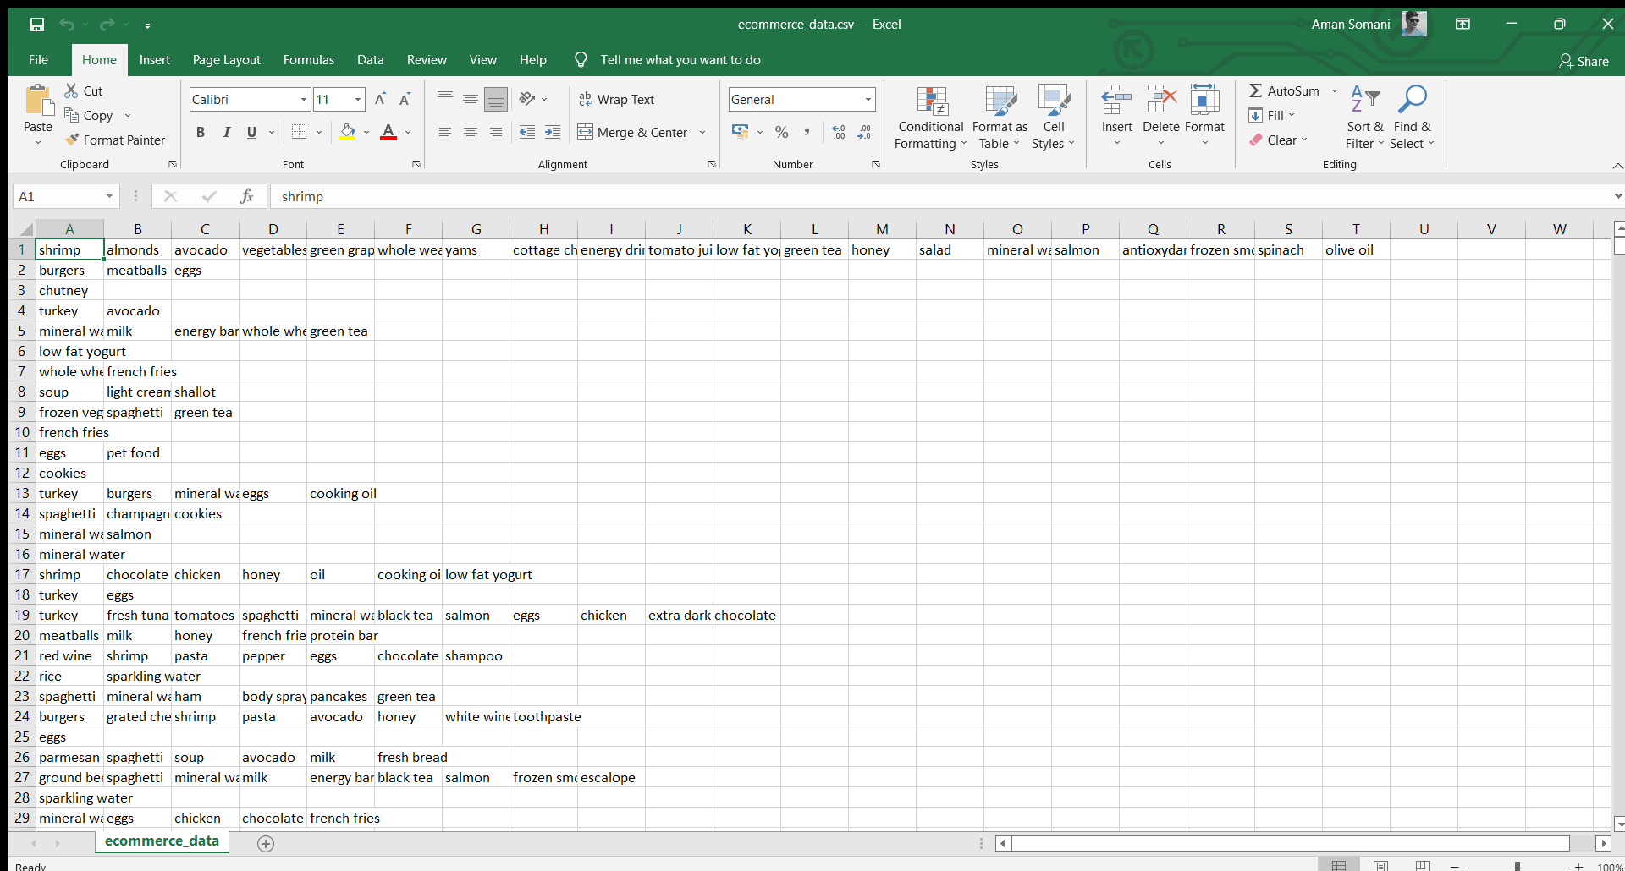

Fig1.

**Proposed Algorithms With Flowchart:**

Initially the dataset is taken as input and then the pre-processing of the data in the dataset takes place. Then, two different steps occur parallelly:-

1. Apirori, FP growth and Eclat algorithms are applied to the interested section of the dataset.

2. Before applying the mining algorithms the number of entries in the existing dataset is reduced by checking which of them are top selling products. After this is done the algorithms are applied on the resulting reduced dataset.

Once both the above results are obtained the results are compared and then analyzed.

**Apriori algorithm:**

Association rule mining finds interesting associations and/or correlation relationships among large set of data items. Association rules shows attribute value conditions that occur frequently together in a given dataset. A typical and widely used example of association rule mining is Market Basket Analysis. For example, data are collected from the supermarkets. Such market basket databases consist of a large number of transaction records. Each record lists all items bought by a customer on a single purchase transaction. Association rules provide information of this type in the form of “IF-THEN” statements. The rules are computed from the data, an association rule has two numbers that express the degree of uncertainty about the rule.

**FP-GROWTH (Frequent Pattern Growth):**

This algorithm is an improvement to the Apriori method. A frequent pattern is generated without the need for candidate generation. FP growth algorithm represents the database in the form of a tree called a frequent pattern tree or FPtree. This tree structure will maintain the association between the itemset. The database is fragmented using one frequent item. This fragmented part is called “pattern fragment”. The itemset of these fragmented patterns are analyzed. Thus, with this method, the search for frequent itemset is reduced comparatively.

**ECLAT Algorithm:**

The ECLAT algorithm stands for Equivalence Class Clustering and bottom-up Lattice Traversal. It is one of the popular methods of Association Rule mining. It is a more efficient and scalable version of the Apriori algorithm. While the Apriori algorithm works in a horizontal sense imitating the Breadth-First Search of a graph, the ECLAT algorithm works in a vertical manner just like the Depth-First Search of a graph. This vertical approach of the ECLAT algorithm makes it a faster algorithm than the Apriori algorithm.

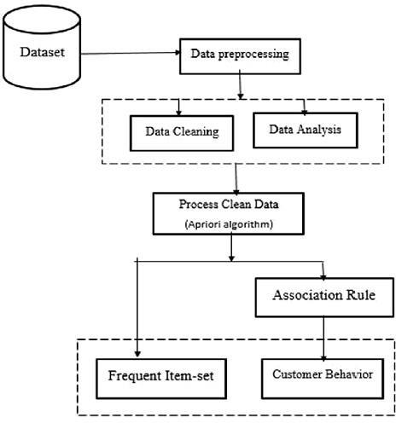

16

Fig2.

**EXPERIMENTS RESULTS:**

The above process generates Association Rules with various fixed metrics such as Support, Confidence, lift, etc. which are used to analyze retail basket or transaction data. These metrics help us understand the strength of association between antecedent and consequent**.**

In our experiment we have made 2 Association Rule with the help of Apriori and FpGrowth and Eclat algorithm.

* + In the first Association rule we have taken minimum support value of frequent item set is 0.05 and confidence of 0.3. For an example when antecedent is chocolate and consequent is mineral water then that means that 30% of the transactions containing chocolate and also contain mineral water.
  + In the Second Association rule we have taken minimum support value of frequent item set is 0.05 and minimum lift value of 1.3. If the lift value is greater than 1that means the probability of occurrence of the antecedent and that of the consequent are greater.

**Implementation :**

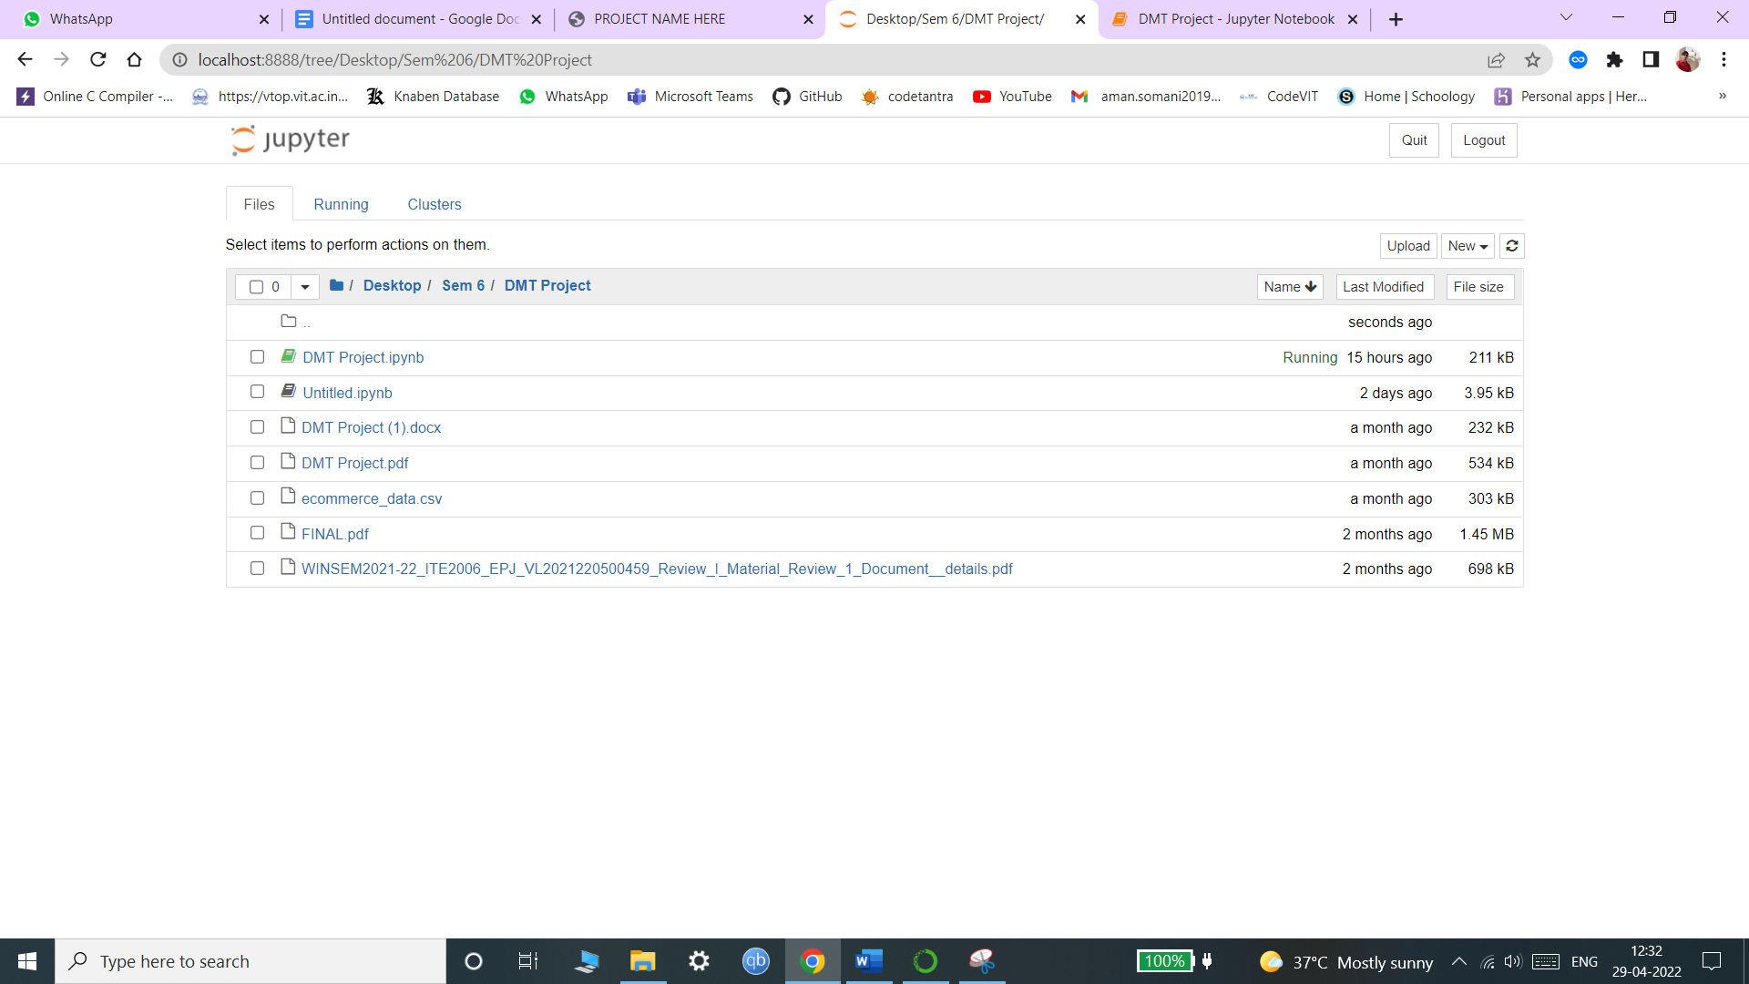We have implemented the code of Apriori ,FP-growth and ECLAT algorithms in Jupyter Notebook.

Fig3.

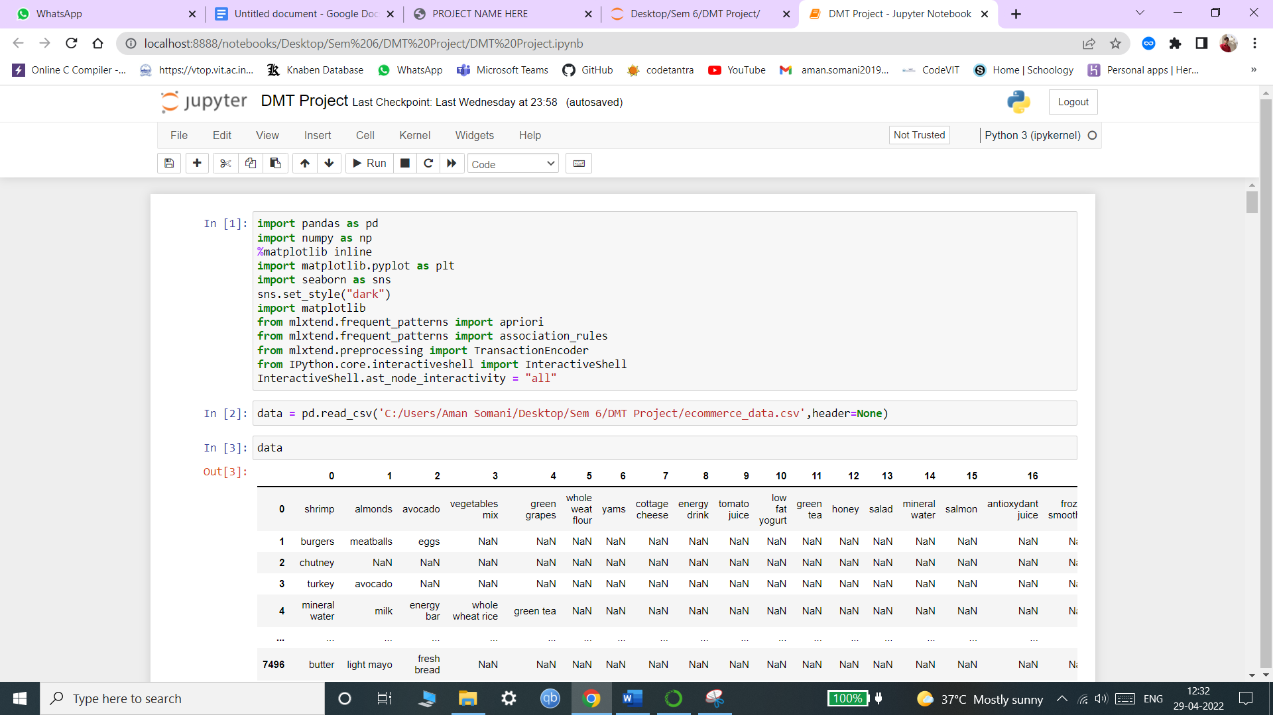Fig4.

**Code Output Screenshots:**

**Importing Libraries:**

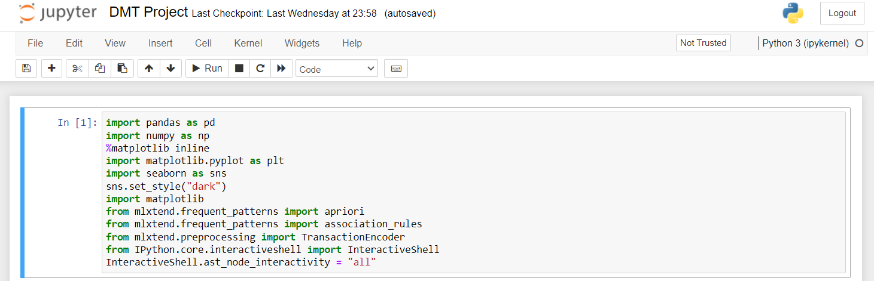

Fig5.

Reading Datasets:

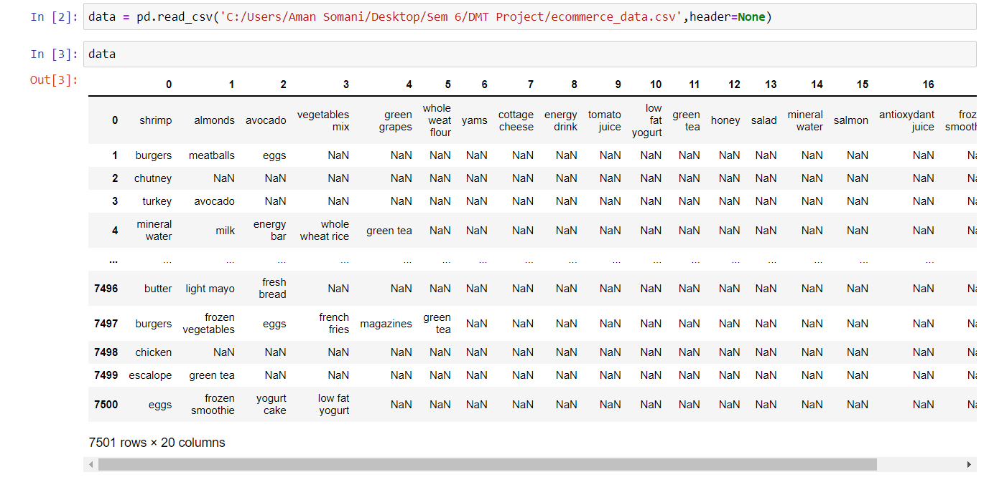

Fig6.

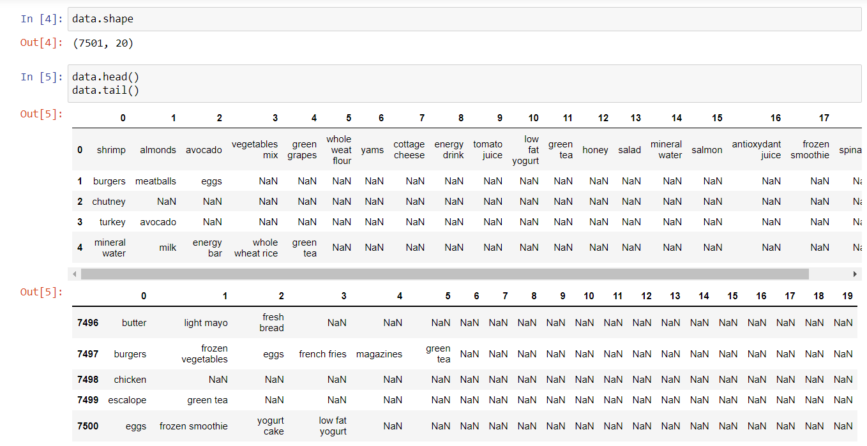

Fig7.

Append the dataset values into an array:

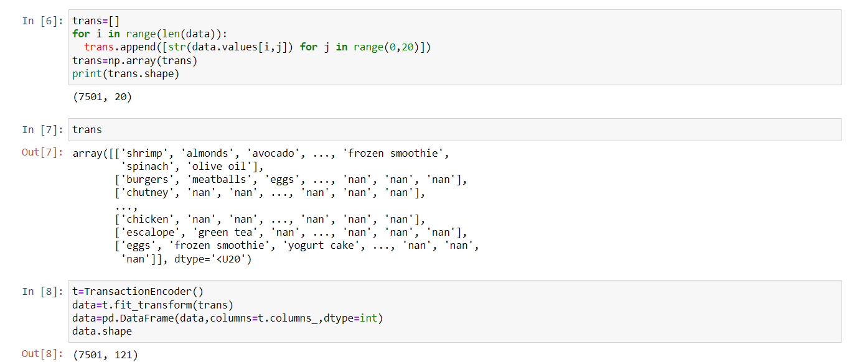

Fig8.

Drop the ‘nan’ values:

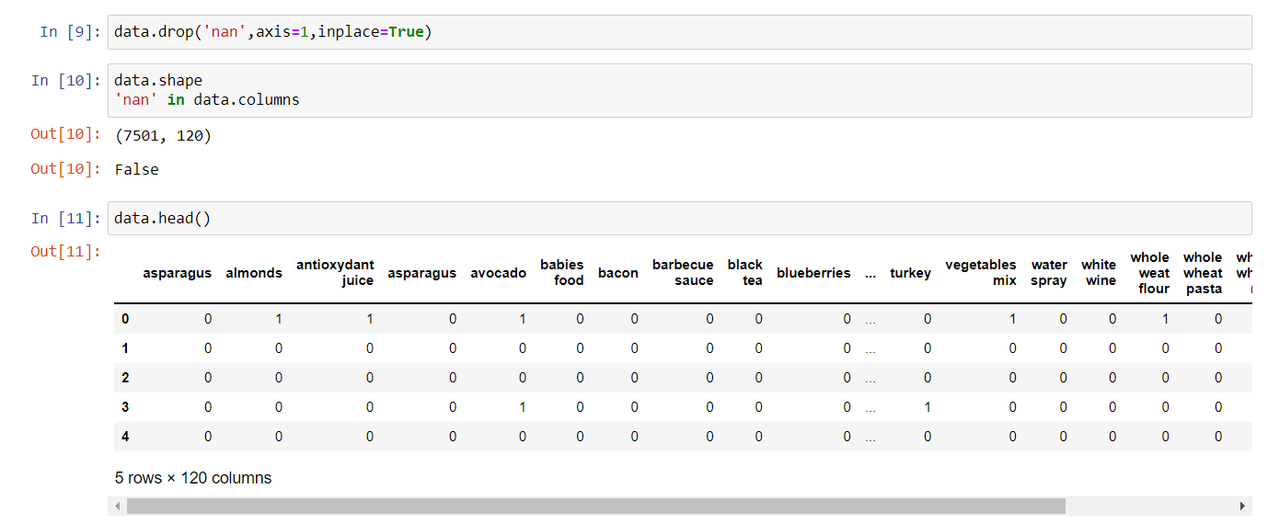 Fig9.

Exploratory Data Analysis (EDA) of 20 top selling items:

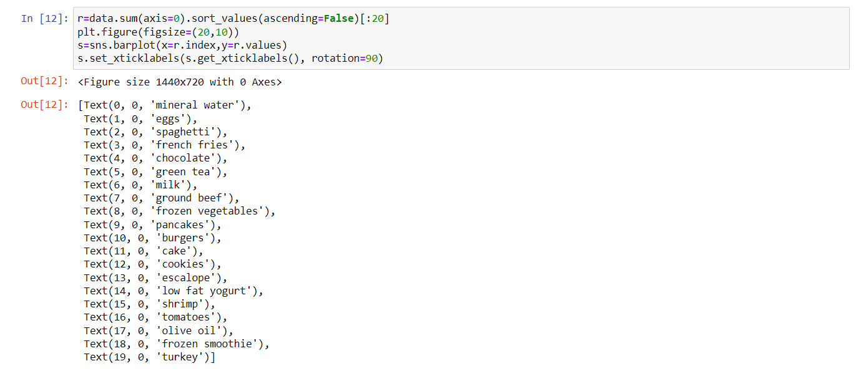

Fig9.

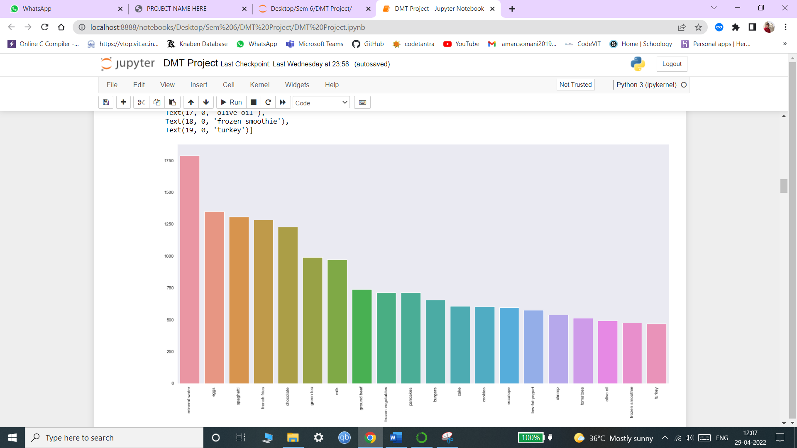 Fig10.

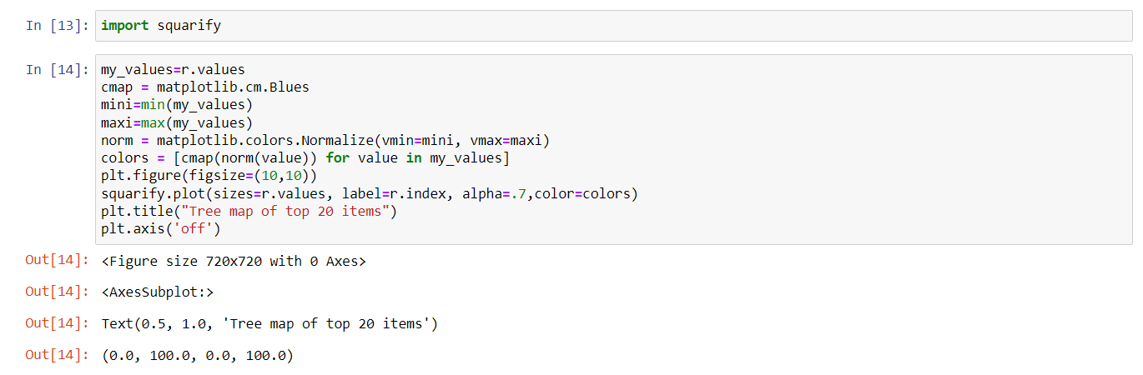Tree Map of the 20 most selling items:

Fig11.

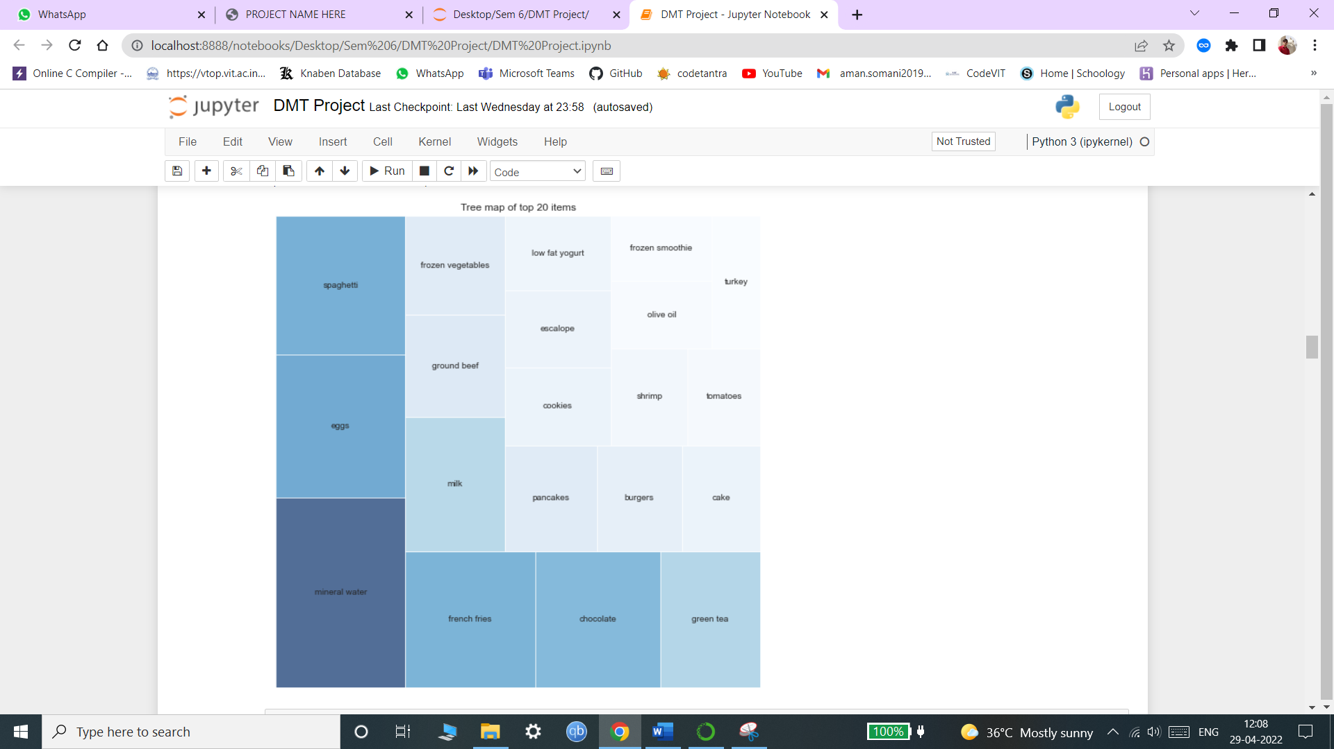

Fig12.

Making frequent items lists using Apriori where minimum support= 0.05:

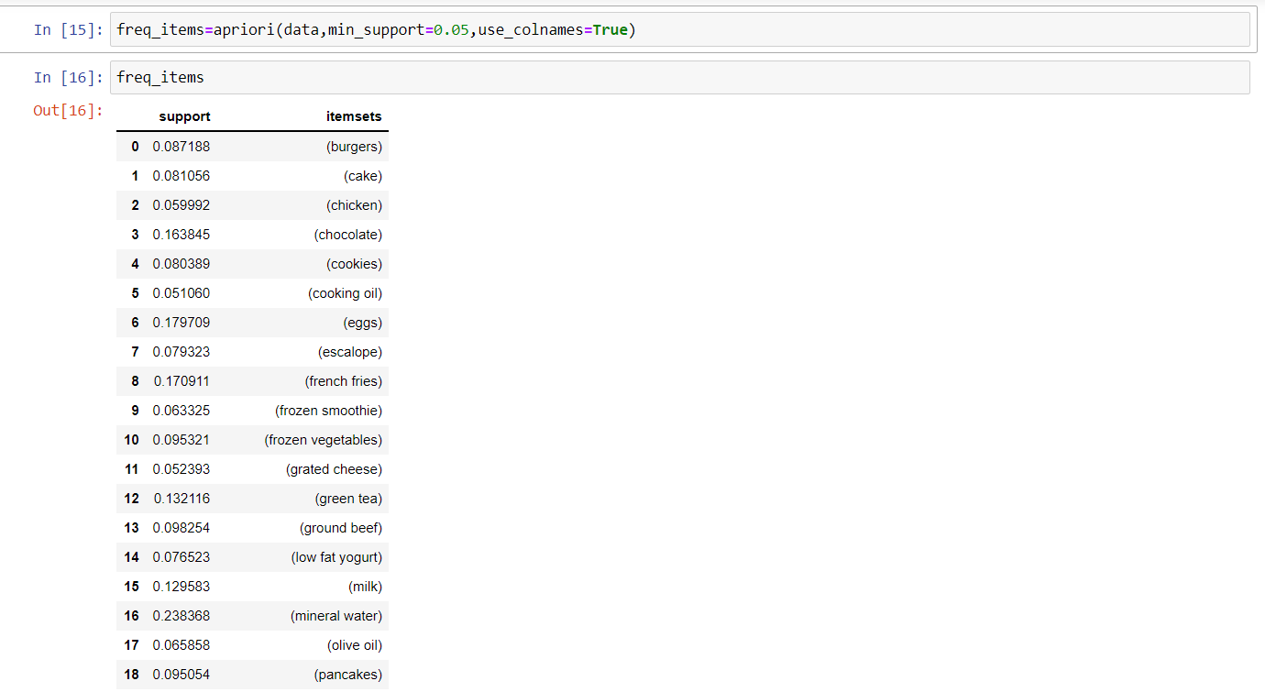

Fig13.

Association rule1 of the freq_items where min_threshold for lift =1.3 :

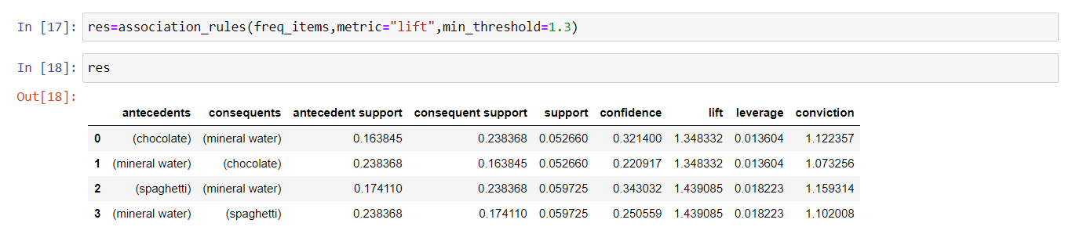

Fig14.

Association rule of the freq_items where min_support= 0.05 and min_confidence =0.3:

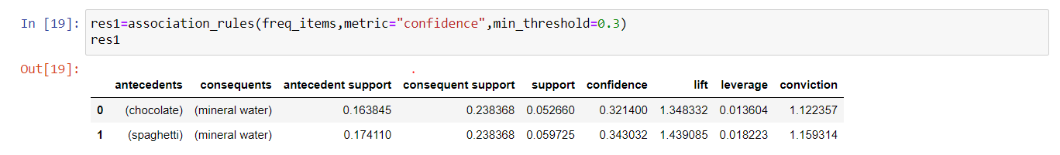

Fig15.

Association rule3 of the freq_items where some selected attributes are displayed:

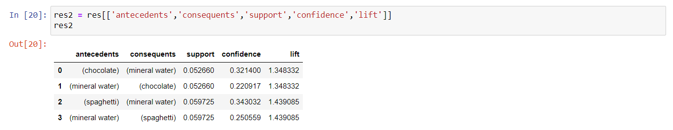

Fig16.

Listing frequent_itemsets where minimum support = 0.05:

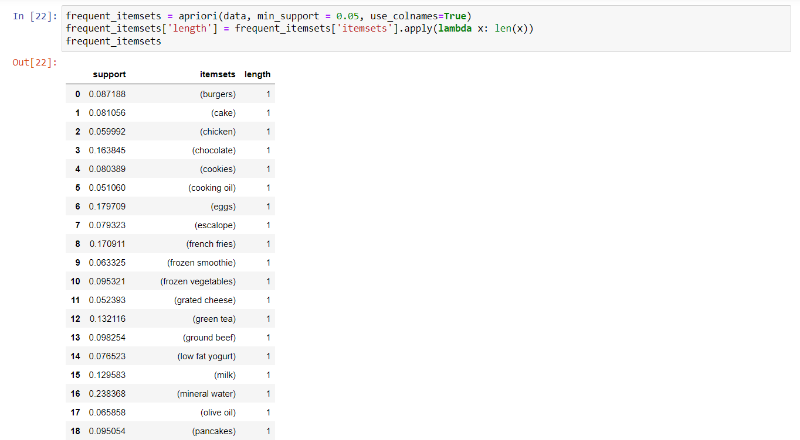

Fig17.

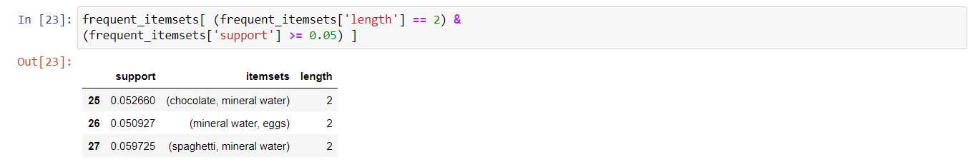Listing items where length of item sets are 2 and support is greater than 0.01 :

Fig18.

Listing items where length of item set is 1 and support is greater than 0.01 :

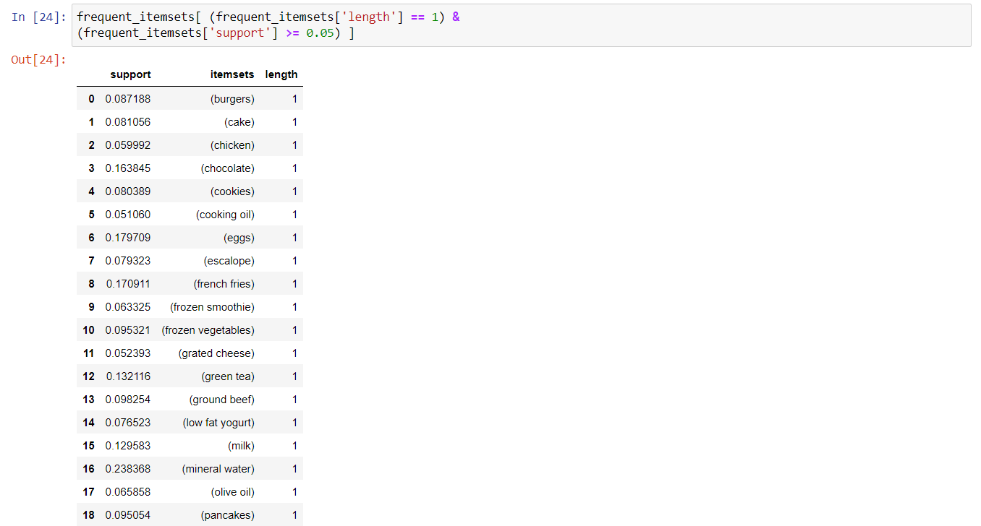

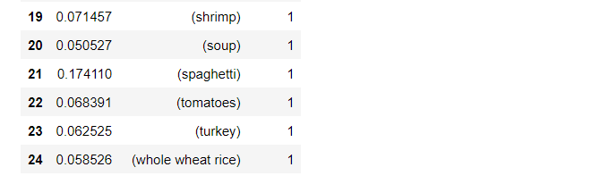

Fig19.

Importing fpgrowth from mlxtend.frequent_patterns:



Fig20.

Making frequent item sets using fpgrowth where minimum support= 0.05:

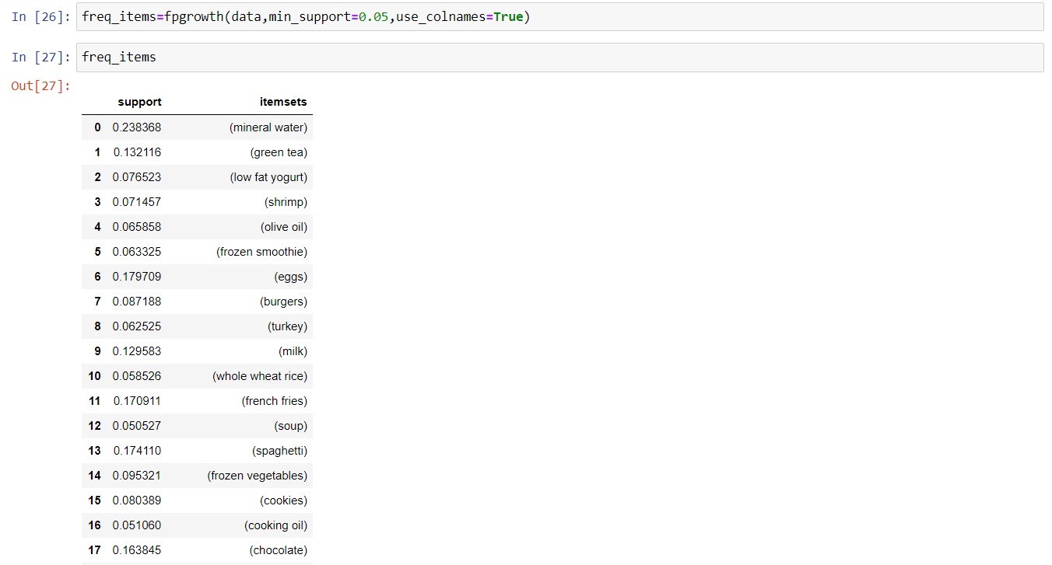

Fig21.

Association rules of the freq_items where min_threshold for lift is 1 and confidence =0.3 :

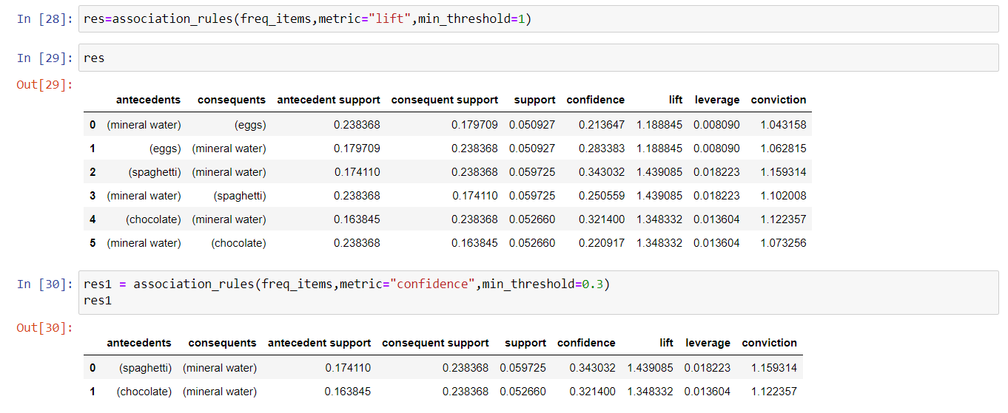

Fig22.

Comparison of RunTime between Apriori and FPGrowth using Barplot and Lineplot:

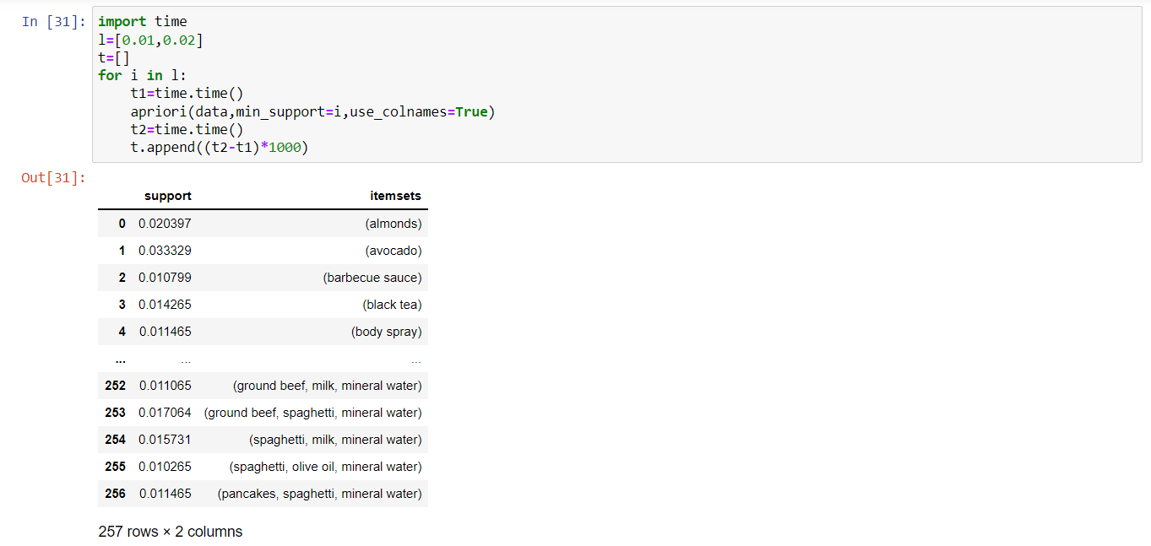

Fig23.

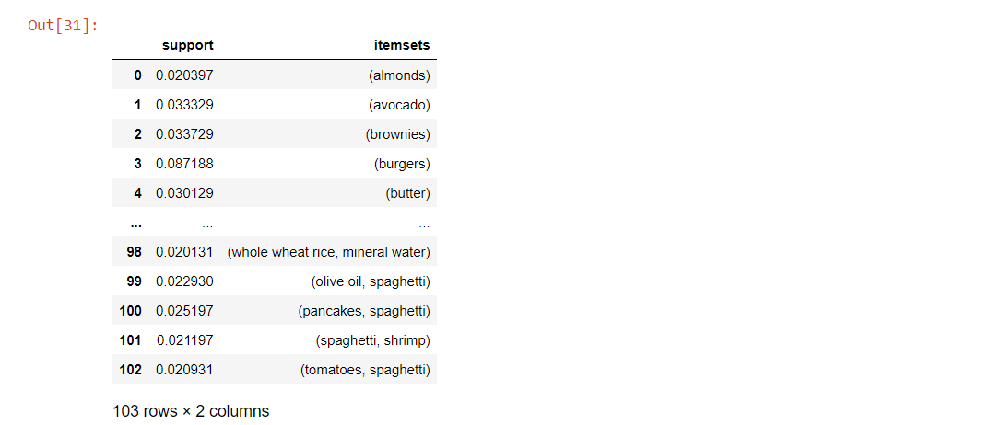

Fig24.

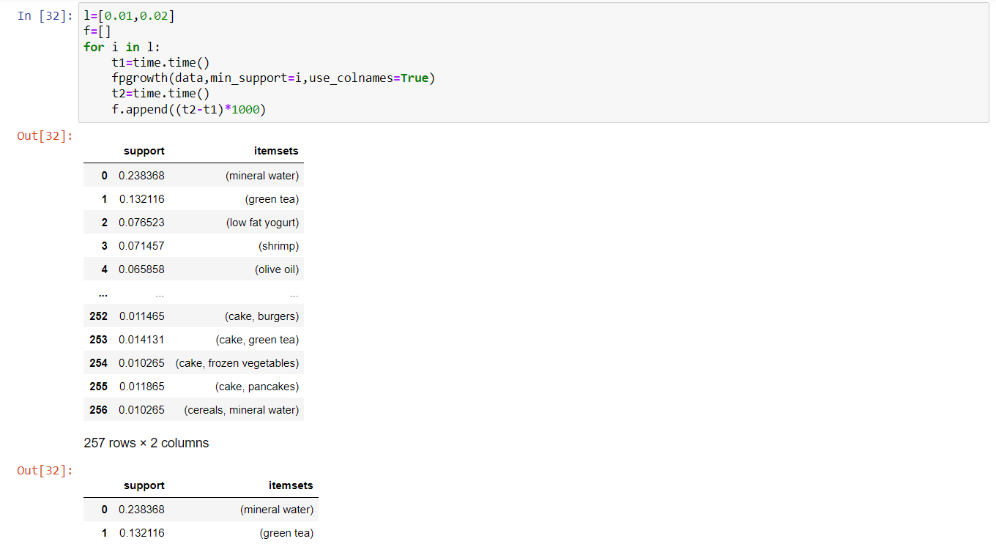

Fig25.

Barplot :

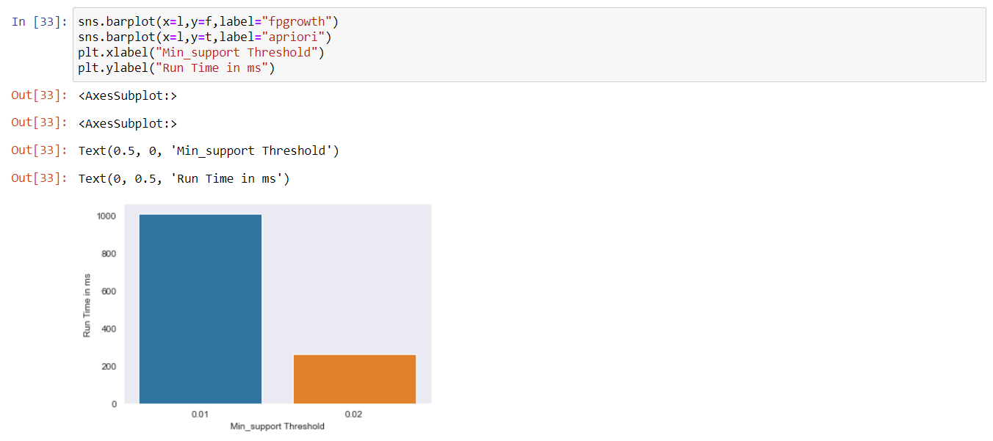

Fig26.

Lineplot :

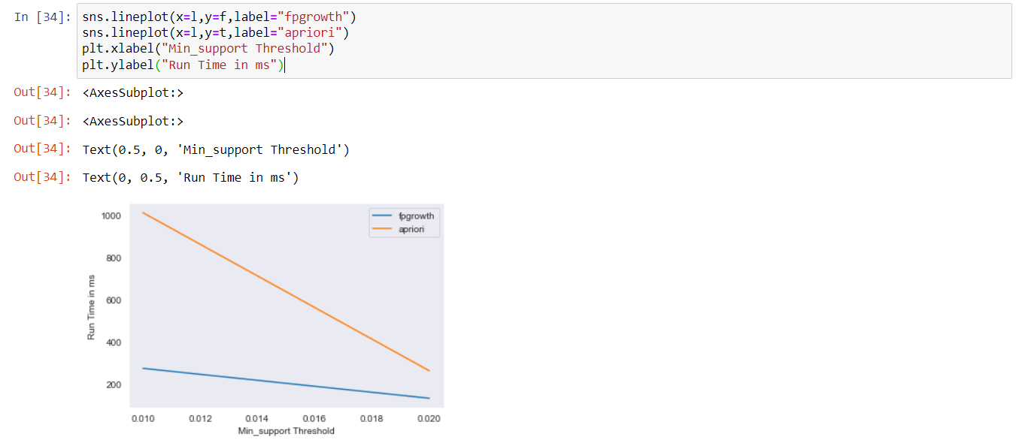

Fig27.

Eclat Algorithm :

Importing the required modules and dataset . After this training the dataset:

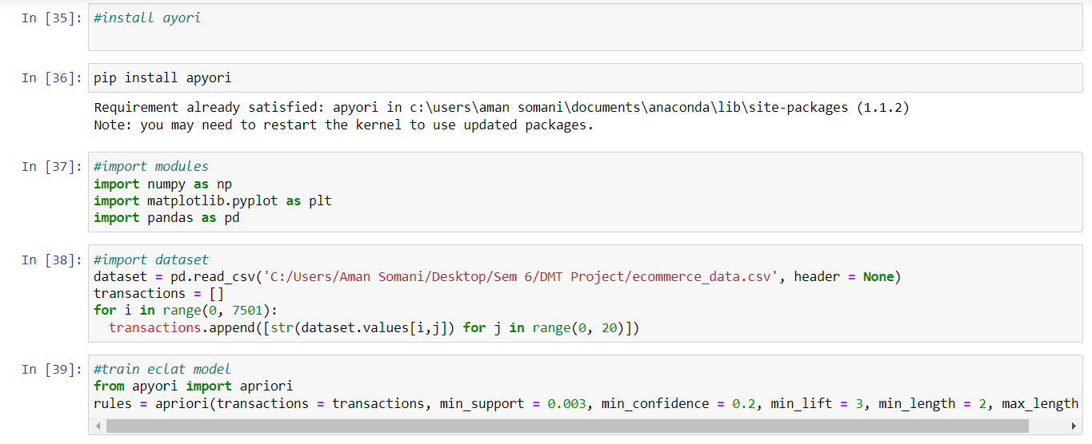

Fig28.

Visualising and organising Data :

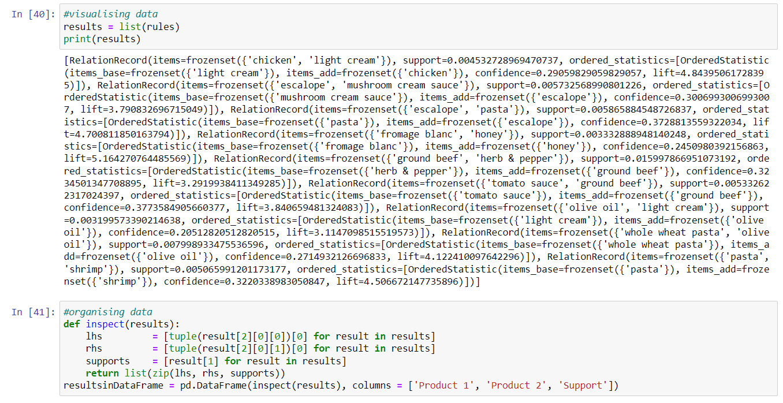

Fig29.

Observing the results obtained on the dataset:

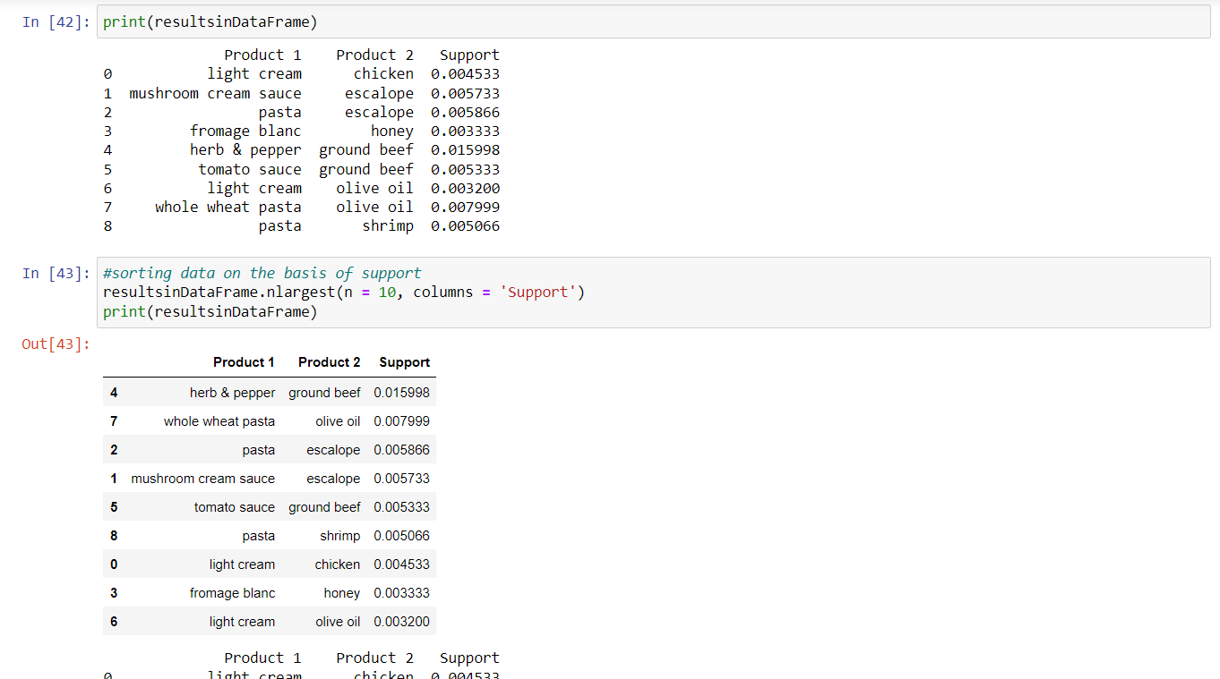

Fig30.

**Code :**

In [1]:

import pandas as pd

import numpy as np

%matplotlib inline

import matplotlib.pyplot as plt

import seaborn as sns

sns.set_style("dark")

import matplotlib

from mlxtend.frequent_patterns import apriori

from mlxtend.frequent_patterns import association_rules

from mlxtend.preprocessing import TransactionEncoder

from IPython.core.interactiveshell import InteractiveShell

InteractiveShell.ast_node_interactivity = "all"

In [2]:

data = pd.read_csv(C:/Users/Aman Somani/Desktop/Sem 6/DMT Project/ecommerce_data.csv',header=None)

In [3]:

data

In [4]:

data.shape

In [5]:

data.head()

data.tail()

In [6]:

trans=[]

for i in range(len(data)):

trans.append([str(data.values[i,j]) for j in range(0,20)])

trans=np.array(trans)

print(trans.shape)

In [7]:

trans

In [8]:

t=TransactionEncoder()

data=t.fit_transform(trans)

data=pd.DataFrame(data,columns=t.columns_,dtype=int)

data.shape

In [9]:

data.drop('nan',axis=1,inplace=True)

In [10]:

data.shape

'nan' in data.columns

In [11]:

data.head()

In [12]:

r=data.sum(axis=0).sort_values(ascending=False)[:20]

plt.figure(figsize=(20,10))

s=sns.barplot(x=r.index,y=r.values)

s.set_xticklabels(s.get_xticklabels(), rotation=90)

In [13]:

import squarify

In [14]:

my_values=r.values

cmap = matplotlib.cm.Blues

mini=min(my_values)

maxi=max(my_values)

norm = matplotlib.colors.Normalize(vmin=mini, vmax=maxi)

colors = [cmap(norm(value)) for value in my_values]

plt.figure(figsize=(10,10))

squarify.plot(sizes=r.values, label=r.index, alpha=.7,color=colors)

plt.title("Tree map of top 20 items")

plt.axis('off')

In [15]:

freq_items=apriori(data,min_support=0.05,use_colnames=True)

In [16]:

freq_items

In [17]:

res=association_rules(freq_items,metric="lift",min_threshold=1.3)

In[18]:

res

In [19]:

res1=association_rules(freq_items,metric="confidence",min_threshold=0.3)

res1

In [20]:

res2 = res[['antecedents','consequents','support','confidence','lift']]

res2

In [21]:

res3= res[res['confidence']>=0.1]

res3

In [22]:

frequent_itemsets = apriori(data, min_support = 0.05, use_colnames=True)

frequent_itemsets['length'] = frequent_itemsets['itemsets'].apply(lambda x: len(x))

frequent_itemsets

In [23]:

frequent_itemsets[ (frequent_itemsets['length'] == 2) &

(frequent_itemsets['support'] >= 0.05) ]

In [24]:

frequent_itemsets[ (frequent_itemsets['length'] == 1) &

(frequent_itemsets['support'] >= 0.05) ]

In [25]:

from mlxtend.frequent_patterns import fpgrowth

In [26]:

freq_items=fpgrowth(data,min_support=0.05,use_colnames=True)

In [27]:

freq_items

In [28]:

res=association_rules(freq_items,metric="lift",min_threshold=1)

res

In [29]:

res1 = association_rules(freq_items,metric="confidence",min_threshold=0.3)

res1

In[30]:

import time

l=[0.01,0.02]

t=[]

for i in l:

t1=time.time()

apriori(data,min_support=i,use_colnames=True)

t2=time.time()

t.append((t2-t1)*1000)

In[31]:

l=[0.01,0.02]

f=[]

for i in l:

t1=time.time()

fpgrowth(data,min_support=i,use_colnames=True)

t2=time.time()

f.append((t2-t1)*1000)

In[32]:

sns.lineplot(x=l,y=f,label="fpgrowth")

sns.lineplot(x=l,y=t,label="apriori")

plt.xlabel("Min_support Threshold")

plt.ylabel("Run Time in ms")

In[33]:

sns.barplot(x=l,y=f,label="fpgrowth")

sns.barplot(x=l,y=t,label="apriori")

plt.xlabel("Min_support Threshold")

plt.ylabel("Run Time in ms")

#install ayori

#pip install apyori

#import modules

import numpy as np

import matplotlib.pyplot as plt

import pandas as pd

#import dataset

dataset = pd.read_csv(C:/Users/Aman Somani/Desktop/Sem 6/DMT Project/ecommerce_data.csv', header = None)

transactions = []

for i in range(0, 7501):

transactions.append([str(dataset.values[i,j]) for j in range(0, 20)])

#train eclat model

from apyori import apriori

rules = apriori(transactions = transactions, min_support = 0.003, min_confidence = 0.2, min_lift = 3, min_length = 2, max_length = 2)

#visualising data

results = list(rules)

print(results)

#organising data

def inspect(results):

lhs = [tuple(result[2][0][0])[0] for result in results]

rhs = [tuple(result[2][0][1])[0] for result in results]

supports = [result[1] for result in results]

return list(zip(lhs, rhs, supports))

resultsinDataFrame = pd.DataFrame(inspect(results), columns = ['Product 1', 'Product 2', 'Support'])

print(resultsinDataFrame)

#sorting data on the basis of support

resultsinDataFrame.nlargest(n = 10, columns = 'Support')

print(resultsinDataFrame)

**COMPARITIVE STUDY/RESULTS AND DISCUSSIONS:**

**Comparative Study: Apriori Vs FP-Growth Vs Eclat:**

Apriori scans the dataset in each of its steps, so it becomes time-consuming for data where the number of items is larger.

FP-Growth requires only one scan of the dataset in its beginning steps so it consumes less time.

The ECLAT algorithm does not involve the repeated scanning of the data to compute the individual support values.

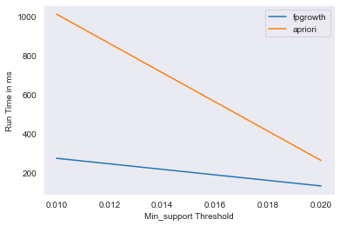

Line plot for Apriori Vs FP-Growth

Fig31.

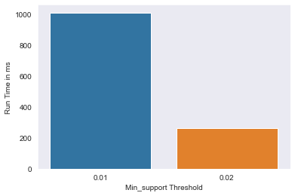

Bar plot for Apriori Vs FP-Growth

Fig32.

As we can see clearly in the diagram that the FP growth algorithm takes much lesser time than Apriori.

**Results:** Association Rules are generated for Apriori and FPgrowth algorithm for antecedent and consequent items in our dataset.

Association rule of the freq_items where min_support= 0.05 and min_confidence =0.3:



Fig 33.

Association rule of the freq_items where min_support= 0.05 and min_threshold for lift =1.3:



Fig34.

Tree Map of the 20 most selling items:

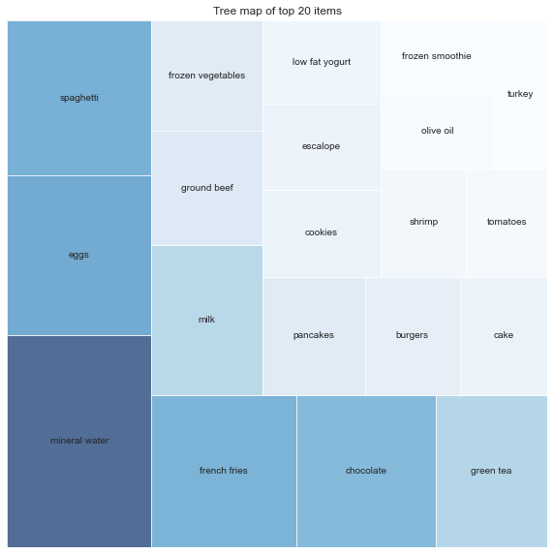

Fig 35.

Bar Plot of 20 top selling items in our dataset:

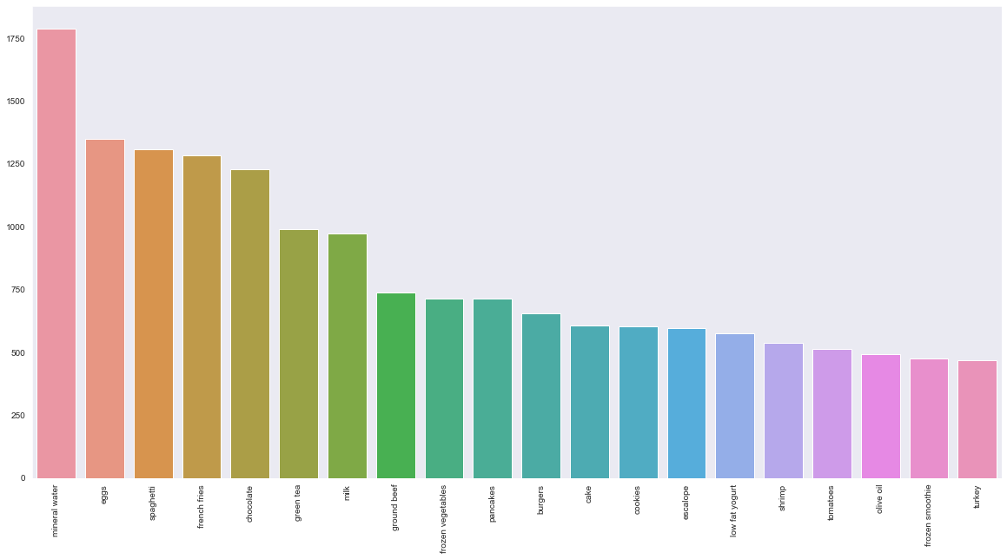

Fig36.

**CONCLUSION AND FUTURE WORK:**

**Conclusion:** From the output above, we see that the top associations are not surprising, with one item for a specific purpose gets purchased along with another flavour required for the same purpose: E.g.: - Bread and Butter are strongly associated as they are consumed together. Similarly, Toothbrush and Toothpaste, Chocolate and Chips, Soap and Shampoo also have strong associations as they are frequently purchased together and used for similar purposes.

**Future Work**: In the future, once common application of association rules mining is in the domain of recommender systems and item pairs have been identified as having positive relationship, recommendations can be made to customers in order to increase sales. Also, there is a possibility of introducing customers to items they never would have tried before.

**References:**

<https://www.sciencedirect.com/science/article/pii/S1877050916305208>

<https://www.researchgate.net/publication/228913454_An_Implementation_of_the_FP-growth_Algorithm>

<https://www.researchgate.net/publication/329515220_Performance_Analysis_of_Apriori_and_FP-Growth_Algorithms_Association_Rule_Mining>

<https://www.irjet.net/archives/V8/i5/IRJET-V8I5831.pdf>

<https://www.ijeat.org/wp-content/uploads/papers/v9i2/B3186129219.pdf>

<https://ieeexplore.ieee.org.egateway.vit.ac.in/document/9410737?arnumber=9410737>

<https://dl.acm.org.egateway.vit.ac.in/doi/10.1145/3377170.3377226>

<https://www.proquest.com/docview/1789980619?accountid=38207>

<https://www.researchgate.net/publication/342382244_Consumer_purchase_patterns_based_on_market_basket_analysis_using_apriori_algorithms>

<https://www.researchgate.net/publication/251422282_FPTree_Based_Algorithms_Analysis_FP_Growth_COFI-Tree_and_CT-PRO>

<https://www.researchgate.net/publication/352384736_Online_Shopping_Do_Men_Behave_Differently_than_Women>

<https://www.researchgate.net/publication/351112666_Uncovering_Modern_Clinical_Applications_of_Fuzi_and_Fuzi-Based_Formulas_A_Nationwide_Descriptive_Study_With_Market_Basket_Analysis>

<http://citeseerx.ist.psu.edu/viewdoc/download?doi=10.1.1.299.6609&rep=rep1&type=pdf>

<http://www.ijsred.com/volume2/issue2/IJSRED-V2I2P83.pdf>

<https://sci-hub.hkvisa.net/10.1109/ICAIBD49809.2020.9137436>

<https://arxiv.org/ftp/arxiv/papers/1403/1403.3948.pdf>

<https://osf.io/preprints/inarxiv/jpsfa/>

<https://ieeexplore.ieee.org.egateway.vit.ac.in/document/9689770>

<https://ieeexplore.ieee.org.egateway.vit.ac.in/document/8262592>

<https://www.proquest.com/docview/2571494191/fulltextPDF/76BE6BE78A804ADFPQ/1?accountid=38207>

<https://www.proquest.com.egateway.vit.ac.in/docview/1789980619/fulltextPDF/DB0BE13D8FDC4517PQ/1?accountid=38207>

<https://eds.p.ebscohost.com.egateway.vit.ac.in/eds/viewarticle/render?data=dGJyMPPp44rp2%2fdV0%2bnjisfk5Ie46bNPtquyS7Ok63nn5Kx94um%2bS62orUquqLA4trCyS7imtTi%2fw6SM8Nfsi9%2fZ8oHt5Od8u6ixUbasr1Gwr6SL59q7S%2bGtskiy3OFFt9q2fKuq5E6xo997r9erfeSrsH3h2OF9s6fgWPDb4oHxnOp57N27feyc4nq72%2bKL4%2bLhPvLX5VW%2fxKR57LPjfPHb6nusqKtNsKSuRbarrk%2bvqLdIs6qwPuTl8IXf6rt%2b8%2bLqjOPu8gAA&vid=2&sid=3c7404fc-9d8d-4f63-ac1a-ef52ecbce51b@redis>

<https://www.sciencedirect.com.egateway.vit.ac.in/science/article/pii/S0378437119302171#sec5>

<https://pubs.acs.org.egateway.vit.ac.in/doi/10.1021/acs.analchem.5b04182>

<https://ieeexplore.ieee.org.egateway.vit.ac.in/document/7033341>

<https://www.sciencedirect.com.egateway.vit.ac.in/science/article/pii/S0925753507001877?via%3Dihub#aep-abstract-id5>